CSS Quiz 1

**Theory**

Q1) Is CSS Case sensitive?

True/False

Q2) Does setting **margin-top** and **margin-bottom** have an effect on an inline element?

Yes/No

Q3) If you have a **<p>** element with **font-size: 10rem**, will the text be responsive when the user resizes / drags the browser window?

Yes/No

Q4) The pseudo class **:checked** will select inputs with type radio or checkbox, but not **<option>** elements.

True/False

Q5) Does **overflow: hidden** create a new block formatting context?

Yes/No

Q6) Which of the following properties is used to make a font italic or oblique?

A - **font-family**

B - **font-style**

C - **font-variant**

D - **font-weight**

Q7) Which of the following defines a measurement in picas?

A - **in**

B - **mm**

C - **pc**

D - **pt**

Q8) What is the hexadecimal code to represent blue colour in CSS coding.

A - #**FF0000**

B - #**FF00FF**

C - #**00FFFF**

D - #**0000FF**

Q9) Consider the following HTML and CSS code:

On page load, will **mypic.jpg** get downloaded by the browser?

Yes/No

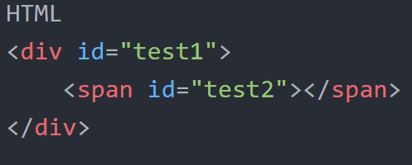

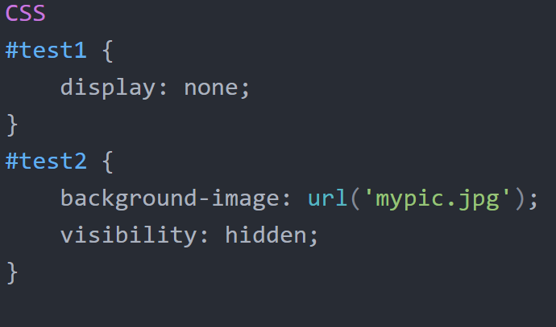

Q10) Consider the following HTML and CSS code:

Does **overflow: hidden** create a new block formatting context?

Yes/No

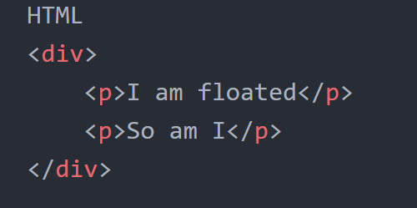

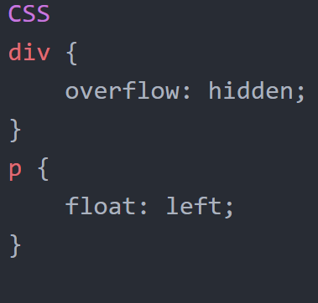

**Practical Application I**

Consider the following HTML code

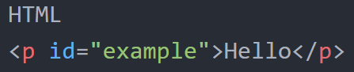

Q1) if this CSS was applied to the above HTML, what will happen to the position of **#example**?

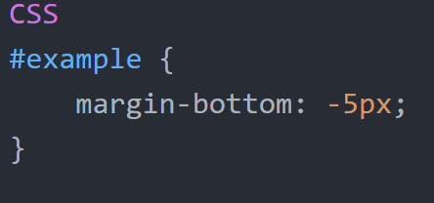

A - All Elements succeeding #example will move 5px downwards

B - All Elements succeeding #example will move 5px upwards

C - Neither

Q2) if this CSS was applied to the above HTML, what will happen to the position of **#example**?

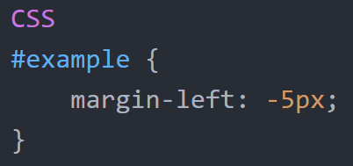

A - All Elements succeeding #example will move 5px left

B - All Elements succeeding #example will move 5px right

C - Neither

**Practical Application II**

Consider the following HTML code

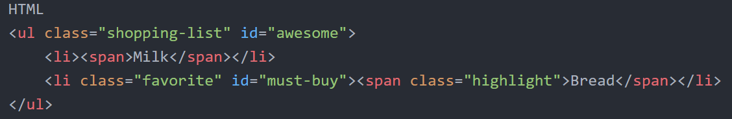

Q1) if this CSS was applied to the above HTML, what is the colour of the text **Bread**?

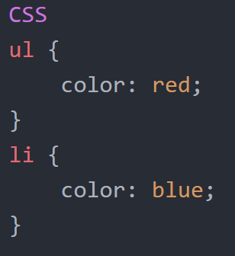

A - Red

B - Blue

C - Neither

Q2) if this CSS was applied to the above HTML, what is the colour of the text **Bread**?

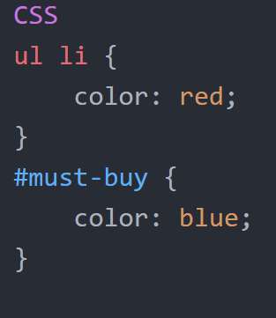

A - Red

B - Blue

C - Neither

Q3) if this CSS was applied to the above HTML, what is the colour of the text **Bread**?

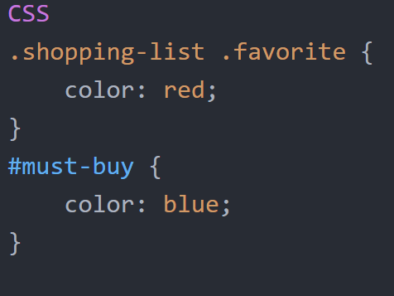

A - Red

B - Blue

C - Neither

Q4) if this CSS was applied to the above HTML, what is the colour of the text **Bread**?

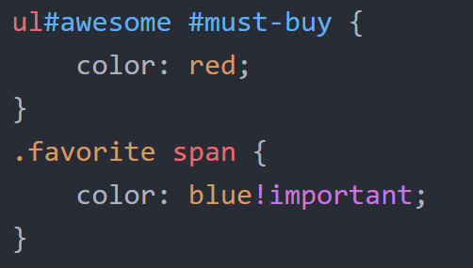

A - Red

B - Blue

C - Neither

Q5) if this CSS was applied to the above HTML, what is the colour of the text **Bread**?

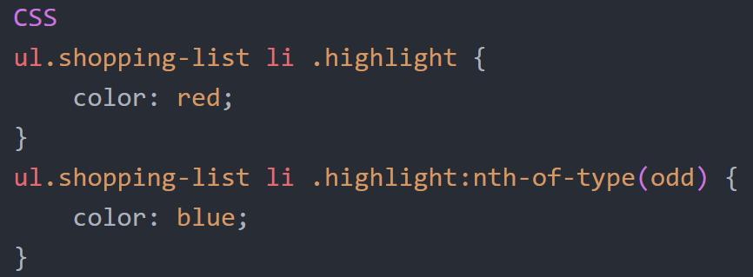

A - Red

B - Blue

C - Neither

Q6) if this CSS was applied to the above HTML, what is the colour of the text **Bread**?

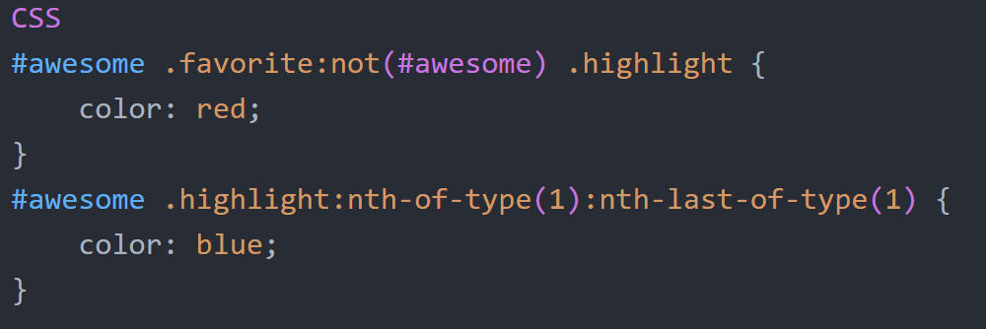

A - Red

B - Blue

C - Neither

**Code Text**

**Theory**

**Q9**

<div id="test1">

<span id="test2"></span>

</div>

#test1 {

display: none;

}

#test2 {

background-image: url('mypic.jpg');

visibility: hidden;

}

**Q10**

<div>

<p>I am floated</p>

<p>So am I</p>

</div>

div {

overflow: hidden;

}

p {

float: left;

}

**Practical Application I**

<p id="example">Hello</p>

**Q1**

#example {

margin-bottom: -5px;

}

**Q2**

#example {

margin-left: -5px;

}

**Practical Application II**

<ul class="shopping-list" id="awesome">

<li><span>Milk</span></li>

<li class="favorite" id="must-buy"><span class="highlight">Bread</span></li>

</ul>

**Q1**

ul {

color: red;

}

li {

color: blue;

**Q2**

ul li {

color: red;

}

#must-buy {

color: blue;

}

**Q3**

.shopping-list .favorite {

color: red;

}

#must-buy {

color: blue;

}

**Q4**

ul#awesome #must-buy {

color: red;

}

.favorite span {

color: blue!important;

}

**Q5**

ul.shopping-list li .highlight {

color: red;

}

ul.shopping-list li .highlight:nth-of-type(odd) {

color: blue;

}

**Q6**

#awesome .favorite:not(#awesome) .highlight {

color: red;

}

#awesome .highlight:nth-of-type(1):nth-last-of-type(1) {

color: blue;

}